MACHINE PROBLEM 5 (MATLAB)

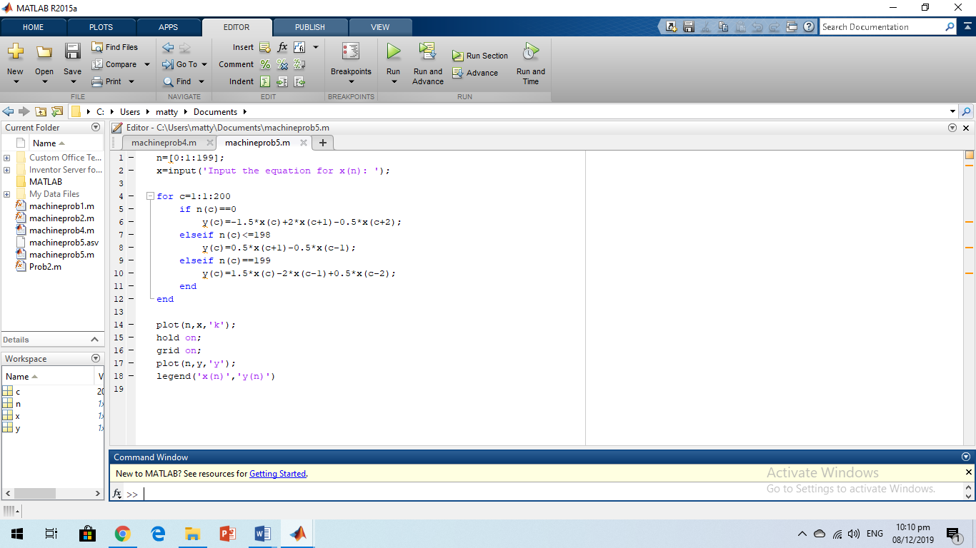

PROOF OF TESTING

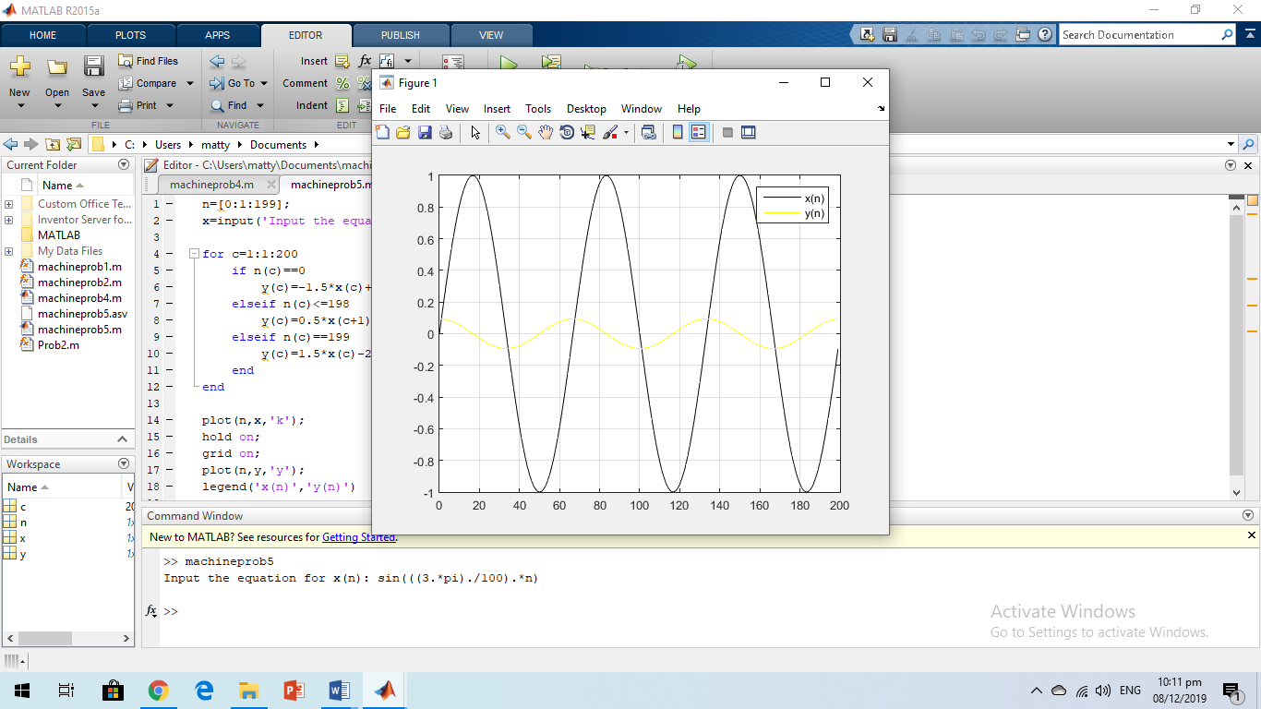

GRAPH

